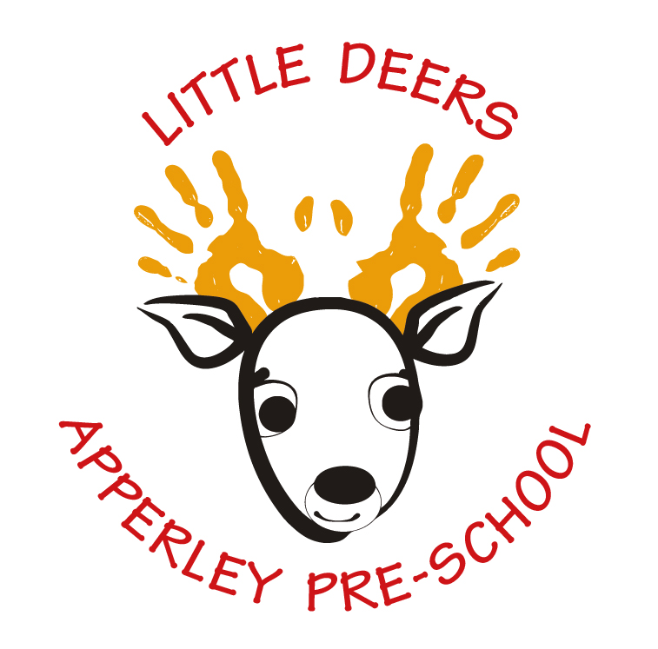

Preschool Admissions Policy
Sept 2024

Learning and living as children of God
(Ephesians 5:1)(You are God’s children whom he loves. Try to be like God)

Statement of Intent and Aim
We aim to make our Preschool accessible to and inclusive of children and families from all sections of the local community through open and fair procedures.

Key Facts

- Our academic year is from 1st September to 31st August.
- We are primarily a preschool for children aged 3-4 years.
- Children usually start primary school reception class in the September of the academic year in which they will turn five.
- Universal Funded Entitlement (UFE) for 3-4 year olds is provided from the Government via the County Council. Every child is eligible for up to 15 hours funded per week for 38 weeks a year from the term after the child turns three.

- Working parents may be entitled to claim up to 30 hours of childcare for 3-4 year olds, known as ‘extended entitlement’ – please check eligibility at www.gov.uk However, Little Deers DOES NOT accept 30-hour funded places.
- Please note that Little Deers only accepts up to 15 hours, but any entitlement can be shared with another setting e.g. another preschool, day nursery, maintained nursery school, registered child-minder, etc.
- Where an academic year exceeds 38 weeks (most are 39 weeks), the additional week(s) will be charged at the standard hourly rate, currently £6/hour.

- When spaces are available, Our OFSTED registration allows us to accept children at the start of the term in which they will turn two years and six months.
- We take children who are eligible for ‘Disadvantaged 2 year olds funded entitlement’. These children will only be accepted if there is a code given by GCC. Families can find out if their child is eligible for funding on the Gloucestershire County Council website.
- We accept the ‘2 year olds funded entitlement for working parents’ of up to 15 hours per week – please check eligibility (Parents will need a code to use this funding)at www.gov.uk.
HOWEVER THIS FUNDING ACCEPTANCE IS CURRENTLY ON A TEMPORARY BASIS AND IS REVIEWED EACH APRIL. PARENTS ARE AT LIBERTY TO PAY IF THEY WOULD LIKE THEIR CHILD TO ATTEND IF WE ARE NOT TAKING THE 2 YEAR FUNDING AT THAT TIME.
- Parents of 2 year olds not entitled to funding yet will pay the standard hourly rate, currently £6/hour, until the child receives their UFE for 3-4 year olds, from the beginning of the term after they turn 3.
- Our staff to child ratios are dictated by the OFSTED statutory guidance.

Pre-School Admissions
Places at Little Deers Apperley Pre-School are allocated primarily on a date of birth policy
We may also take the following into account:
- Special Educational needs
- Referrals from outside agencies
- Particular circumstances affecting the family
- Siblings previously or already attending the Preschool
- The vicinity of the child’s home to the Preschool
Decisions are made on a case-by-case basis.
Placement Lists
The Play Leader holds a placement list, which includes consideration of the child’s current attendance at Little Deers where appropriate, and acts as a notification of intent.

Having your child’s name on the placement list does not guarantee a place at a future date. Spaces cannot be held or reserved (for example, ahead of a summer birthday), even for a fee. Parents wishing to increase their child’s attendance should inform the Play Leader in writing – if a space is not currently available they will join the placement list.

When a place becomes available, it will be offered based on the following order of precedence. Where there are multiple children on the list fulfilling the same criteria, these will be approached in order of date of birth, oldest first:

- Children who currently attend less than 6 hours per week but wish to attend more.
- Children who do not currently attend any sessions Little Deers and wish to start.
- Children who currently attend and have not yet expressed an interest in attending more.

If a place becomes available but the first child on the placement list is unable to start, it will be offered to the next eligible child on the list. Decisions will be made and communicated as promptly and efficiently as possible. Registration cannot be discussed with families other than that of the child in question.

Whilst the Play Leader and Head Teacher make every effort to be fair and considerate and accommodate the wishes of as many children and families as possible, it is not always possible to satisfy everyone. In all cases, the Play Leader’s decision is final.
Policy reviewed with staff and Governors and agreed on 8TH October 2024

Signed: Mrs J. Neveu Head teacher Date: 8/10/24

Signed: Mr Chris Davis Chair of Governors Date: 8/10/24

Please also see:
Little Deers Fees and Nursery Education Grants Fees and Nursery Grants Policy Sept 2024

